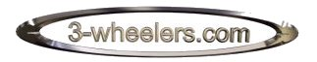
The online A-Z of 3-wheelers.

M6 Toll Road Classification for 3-wheeled Vehicles.

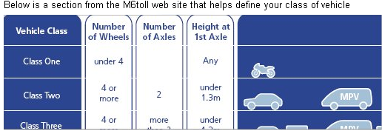

Based on this chart a 3-wheeler falls under Class 1 (Number of wheels - under 4) This means therefore that when you approach the toll booths you can pay the Motorcycle fee (Standard price £2.50 day, £1.50 night). Should they argue that you vehicle is a Car, as a Reliant Robin is, you can state that a car comes under Class Two and is defined as having 4 wheels or more. In addition Class 2 is for vehicles with two axles - a 3-wheeler essentially only has one.
The M6 Toll Press Officer, Nigel Pipkin also sent this e-mail
Dear Sir/Madam,
We at The Warman Group are the newly appointed public relations consultancy for the M6 Toll, operated by Midland Express Ltd. I have been speaking to a Mr R Whitehurst about what he says is 'a forthcoming protest by Reliant Trycycle owners' with regard to tolls being charged for three-wheel vehicles.
I am told the price as stated clearly on the website www.m6toll.co.uk is £2.50, the same as for motorcycles. However, Mr Whitehurst has told me that some people are being charged £3.50. On the face of it, this appears to be incorrect.
Could I seek your help in resolving this. Could one of those people who still retains a receipt for the incorrect amount please contact Jayne Dunn,phone 01543 267024.
Please excuse the formality of the 'Dear Sir/Madam' as I am obviously unaware of your christian name.
If you have any futher difficulties please drop me a line.
Kind regards
Nigel Pipkin
The rules are clear, all Reliants pay only Class 1 prices for using the toll road and all of their employees have been told this fact. So if they try charging you, tell them to see Nigel Pipkin their press officer!
Note: The email above was sent in 2004 and so the prices have been amended on this print out so that they are inline with the current charging scheme. This is not to try and hoodwink anyone but just so that current prices are displayed rather than older ones.

